76th MARY E. PERRY FREEDOM FUND BANQUET
“Always Fighting Forward”
October 16, 2021
Please indicate your advertisement choice by placing a (X) on the appropriate blank.
Enclose the advertising information with (if desired) a photograph. Submit digital ready ads to
wenwakenaacpsec@aol.com

____ Back Cover * $500.00

____ Front & Back inside cover * $500.00

____ Full Page Ad* $250.00

____ Half Page Ad* $125.00

____ Fourth Page Ad * $ 75.00

____ Table $280.00
(8 Tickets)

____ Ticket $ 35.00

____Patron $ 10.00/per name
* Add $10.00 to price if you want a color picture included
TOTAL SUBMITTED WITH CONTRACT $____________
If not digital ready, please type or print your hardcopy advertisement as it is to appear in the Souvenir booklet. Make your check or money order payable to: WENDELL-WAKE NAACP and mail it along with this contract and your advertisement layout to:
Wendell-Wake NAACP
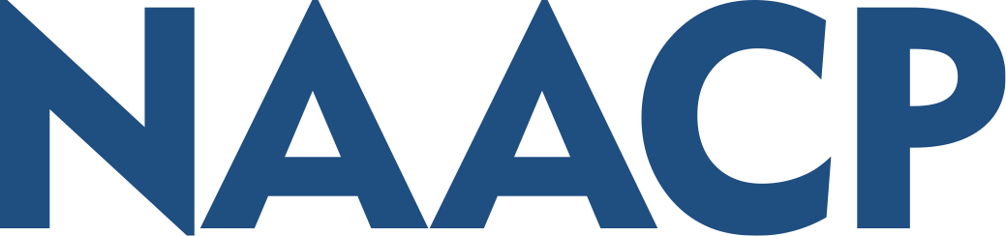
Mary E. Perry Freedom Fund Banquet
Wendell-Wake
P.O. Box 46648
Raleigh, North Carolina 27620
Advertisements and monies must be received no later than September 30, 2021. Questions call (919) 332-3693.
This advertisement is authorized by:

Name(Business): _______________________________________________________________________

Address: ______________________________________________________________________________

City: _____________________________ State: _________ Zip Code:_____________________________

Contact phone/email (if we have questions) ___________________________________________________

Signature ______________________________________________ Date: __________________________
COMMITTEE USE ONLY
Check Number _________ Date Received ___________

Check Amount _________ Ad Received ____________

Contributions and gifts to the NAACP Unit are generally not deductible as charitable contributions for Federal income tax purposes.

